**GENIATECH Rockchip RK3588 Development Board**

**DB3588**

RK3588 Development Board is featured with powerful performance, rich interface and high stability. It is based on Rockchip RK3588’s new generation flagship octa-core 64-bit processor. With a maximum of 32GB memory.

RK3588 Development Board supports 8K video decoder and encoder, 6Tops computing power, supports mainstream deep learning framework and supports a variety of operating systems. This kind of ARM embedded board can be applied to ARM PC, edge computing, cloud server, intelligent NVR and other fields.

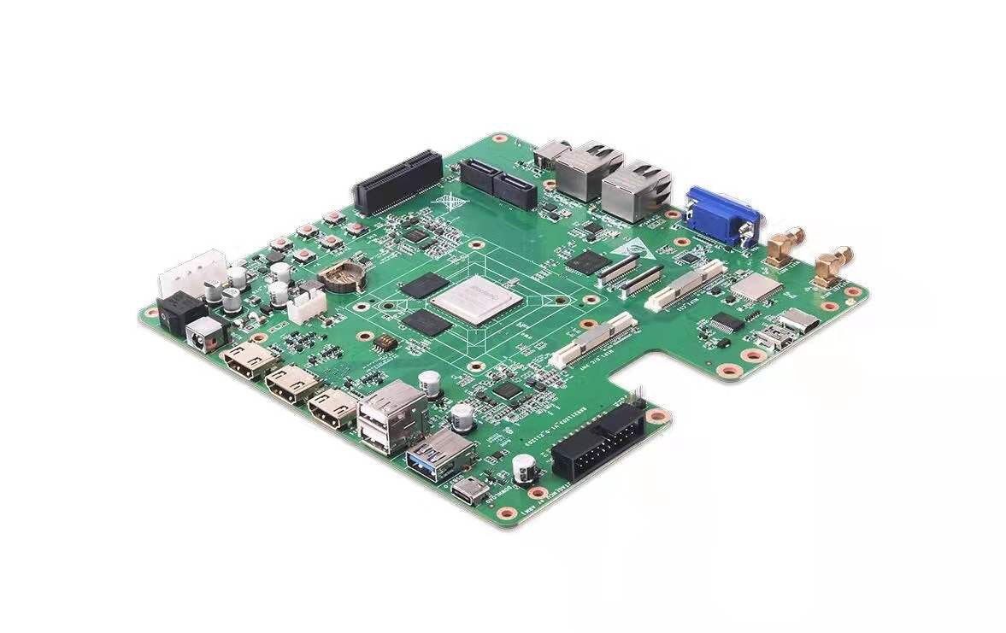

**Features of RK3588 Development Board**

(1) Quad-core Cortex-A76 and quad-core Cortex-A55, build-in NPU up to 6TOPs， and

with GPU Mali-G610 MP4, Android 12 OS or Linux

(2) Support 2~32GB RAM, 8~256GB eMMc flash, external expansion storage Micro

SD card (Max 512GB)

(3) Peripheral interface：USB2.0 * 1, USB3.0 * 1, Type-C *1, Earphone * 1,

Debug(Type-C) * 1, Uart to USB (MiniUSB) *1, JTAG * 1

(4) Display interface：HDMI IN * 1, HDMI OUT * 2, VGA * 1

(5) Build-in：MIPI CSI * 2, MIPI DSI * 1, MIPI D/C PHY * 1, PCIe * 1, SATA * 2, MIC * 2

(6) Network： WIFI6(2.4G+5.8G), BT5.0, GIGA Ethernet * 2

(7) Dimension：180mm * 180mm, Weight：160g

(8) Power supply：Adapter 12V/2A

(9) Launch Time : 2022-03-17

**Diagram of RK3588 Development Board**

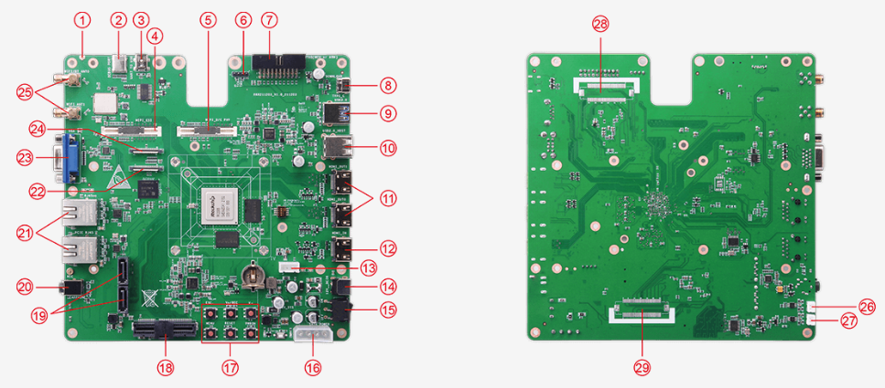

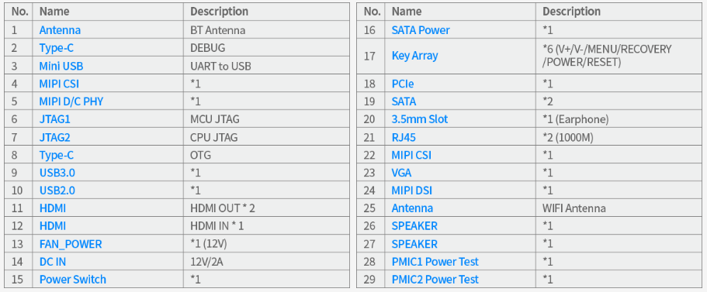

**Product Specification**

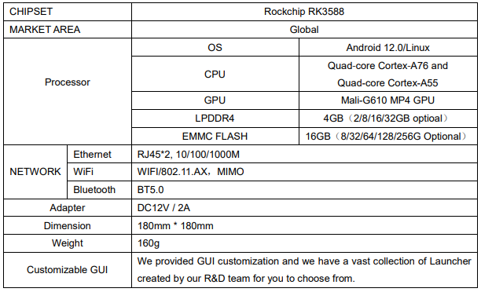

**Support Formats**

**Video Decoder:**

Real-time video decoder of MPEG-1, MPEG-2, MPEG-4, H.263, H.264, VC-1, VP9, VP8, MVC, AV1

MMU Embedded

Multi-channel decoder in parallel for less resolution

H.264 AVC/MVC Main10 L6.0 : 8K@30fps (7680×4320)②

VP9 Profile0/2 L6.1 : 8K@60fps (7680×4320)

MPEG4/MVC Main10 L6.1 : 8K@60fps (7680×4320)

AVS2 Profile0/2 L10.2.6 : 8K@60fps (7680×4320)

AV1 Main Profile 8/10bit L5.3 : 4K@60fps (3840×2160)

MPEG-2 up to MP : 1080p@60fps (1920×1088)

MPEG-1 up to MP : 1080p@60fps (1920×1088)

VC-1 up to AP level 3 : 1080p@60fps (1920×1088)

VP8 version2 : 1080p@60fps (1920×1088)

Video Encoder

Real-time MPEG4/H.264 video encoding

Support up to 8K@30fps

Multi-channel encoder in parallel for less resolution

**Block Diagram**

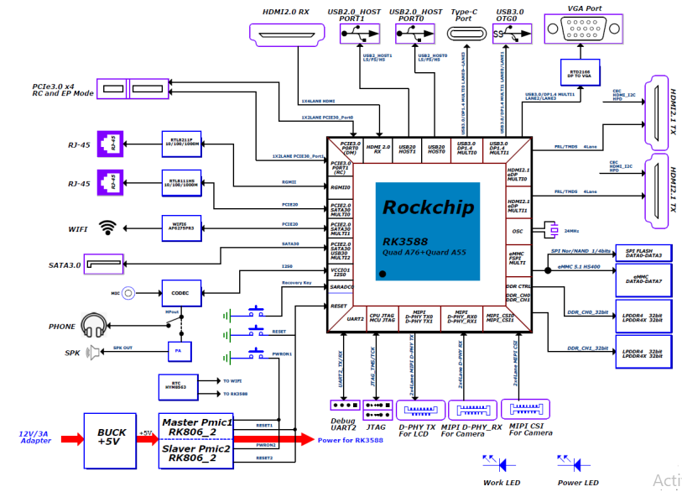

**CONTACT: SHENZHEN OFFICE** + 86 755 86028588